**Name: Yossef El-Sayed Ahmed.**

**B.N: 15.**

**Date: 5/6/2021.**

**Topic: Database System.**

# Application brief:

# Screenshots:

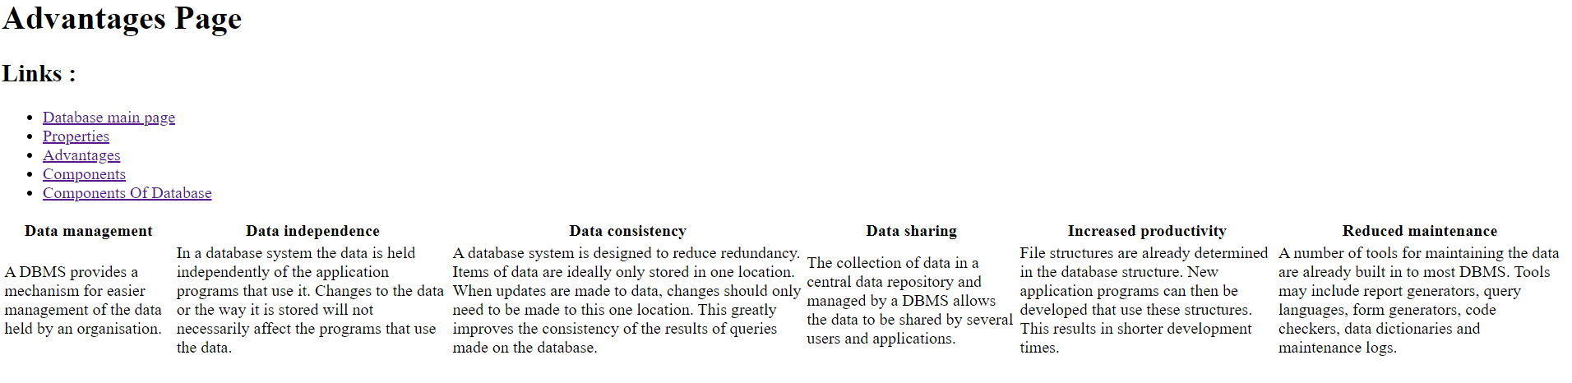

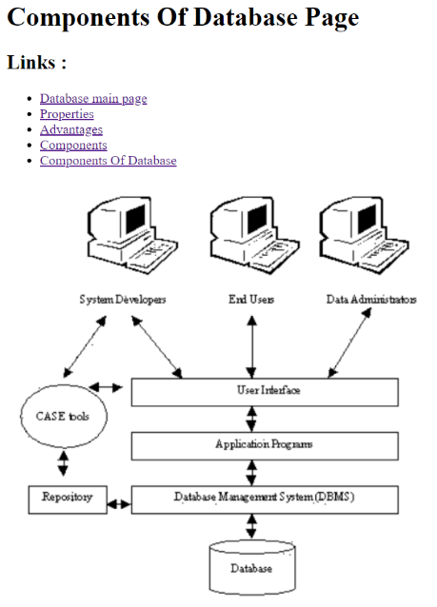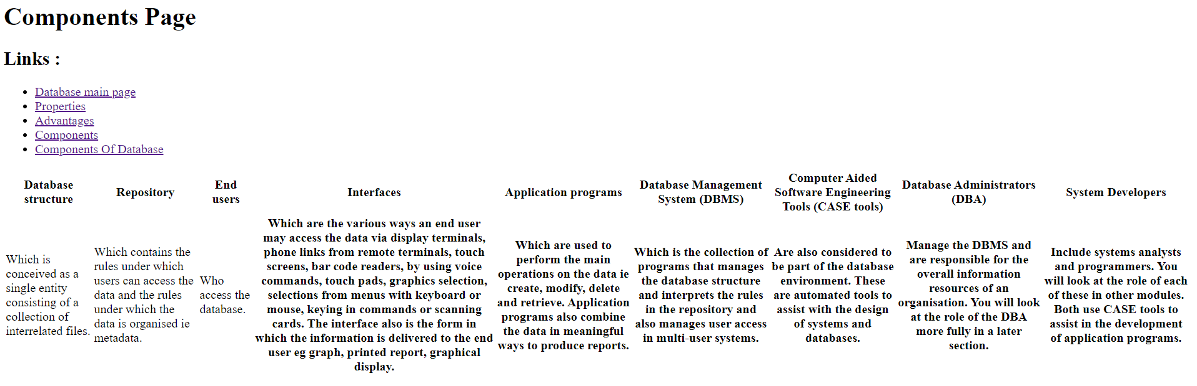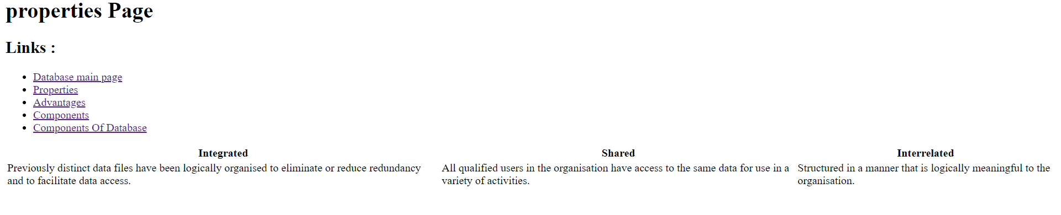

# Source code:

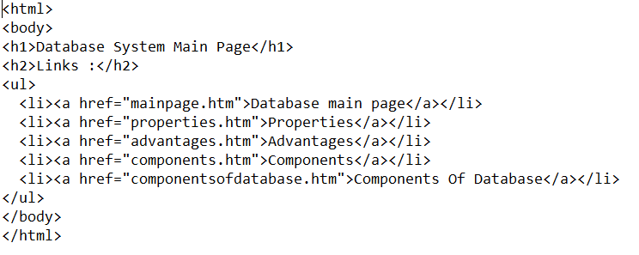

Github link: